 | Planning Division Staff Report  Planning Commission Meeting October 13, 2022  Prepared by: Kinarik Shallow, Associate Planner

ITEM 6.1: Administrative Permit – 1950 Blue Oaks Boulevard – WRSP PCL F-31 – Plaza at Blue Oaks Parking Reduction – File #PL22-0337

REQUEST
The project is a request for an Administrative Permit for a parking reduction to allow a 14% reduction for shared uses located within the Plaza at Blue Oaks center.
Applicant – Joseph Zawidski, Signature Homes
Property Owner – Fiddyment F-31 Retail, LLC

SUMMARY RECOMMENDATION

The Planning Division recommends the Planning Commission take the following actions:

- Adopt the three (3) findings of fact and approve the Administrative Permit subject to three (3) conditions of approval.

SUMMARY OF OUTSTANDING ISSUES

There are no outstanding issues associated with this request. The applicant has reviewed and is in agreement with all recommended conditions of approval.

BACKGROUND
The project site is located on Parcel F-31 in the West Roseville Specific Plan (WRSP) area, at the northeast intersection of Fiddyment Road and Blue Oaks Boulevard (see Figure 1). The site has a zoning and land use designation of Community Commercial (CC). The site consists of the Plaza at Blue Oaks center, which is a retail center anchored by Raley’s O-N-E Market. Surrounding uses include an undeveloped High Density Residential (HDR) parcel to the north across Harvey Way, Fiddyment Ranch Apartments to the east across Oak Meadow Drive, single-family residences to the south across Blue Oaks Boulevard, and a medical office building to the east across Fiddyment Road.
Figure 1: Project Location
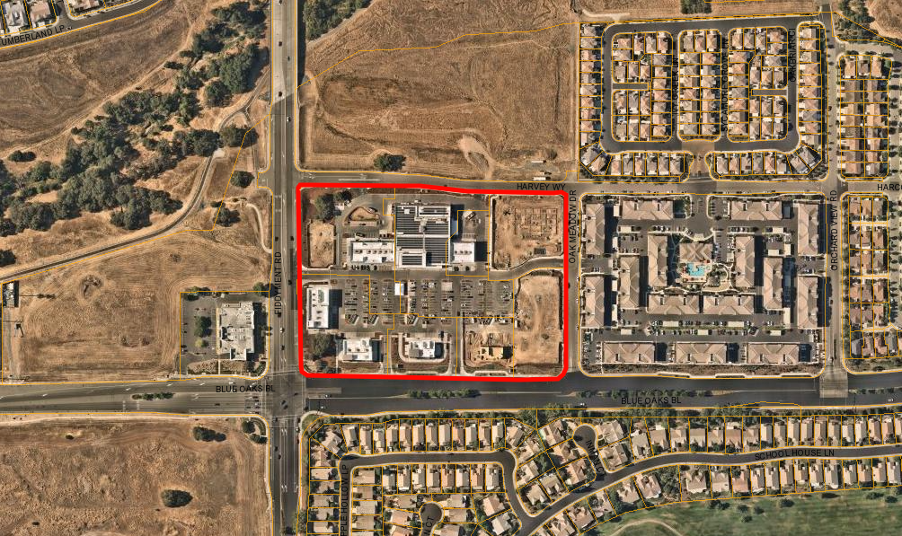
Project Site
Harvey Wy
Fiddyment Bl
Oak Meadow Wy

Blue Oaks Bl

The Plaza at Blue Oaks project was approved by City Council in August 2020 (file #PL17-0368). The project entitlements included a Design Review Permit to allow the construction of an 82,100-square-foot shopping center consisting of a 35,000-square-foot anchor grocery store, a 12-pump gas station with a 3,500-square-foot-convenience store and car wash, and seven additional buildings ranging in size from approximately 3,750 square feet to 9,750 square feet. Figure 2 is the approved site plan for reference. Concurrent with the DRP, a Tentative Subdivision Map was approved to subdivide the 13.35-acre parcel into eight (8) lots and a Tree Permit was approved to remove several native oak trees on the westerly portion of the site. A majority of the buildings have been fully constructed as seen in the aerial image above, with the exception of Phase 2, Pad 2, Pad 3, and Pad 4. With the exception of Raley’s, which has been in operation since June 2022, the tenant spaces are still under construction.
Figure 2: Original Plaza at Blue Oaks Site Plan (PL17-0368)
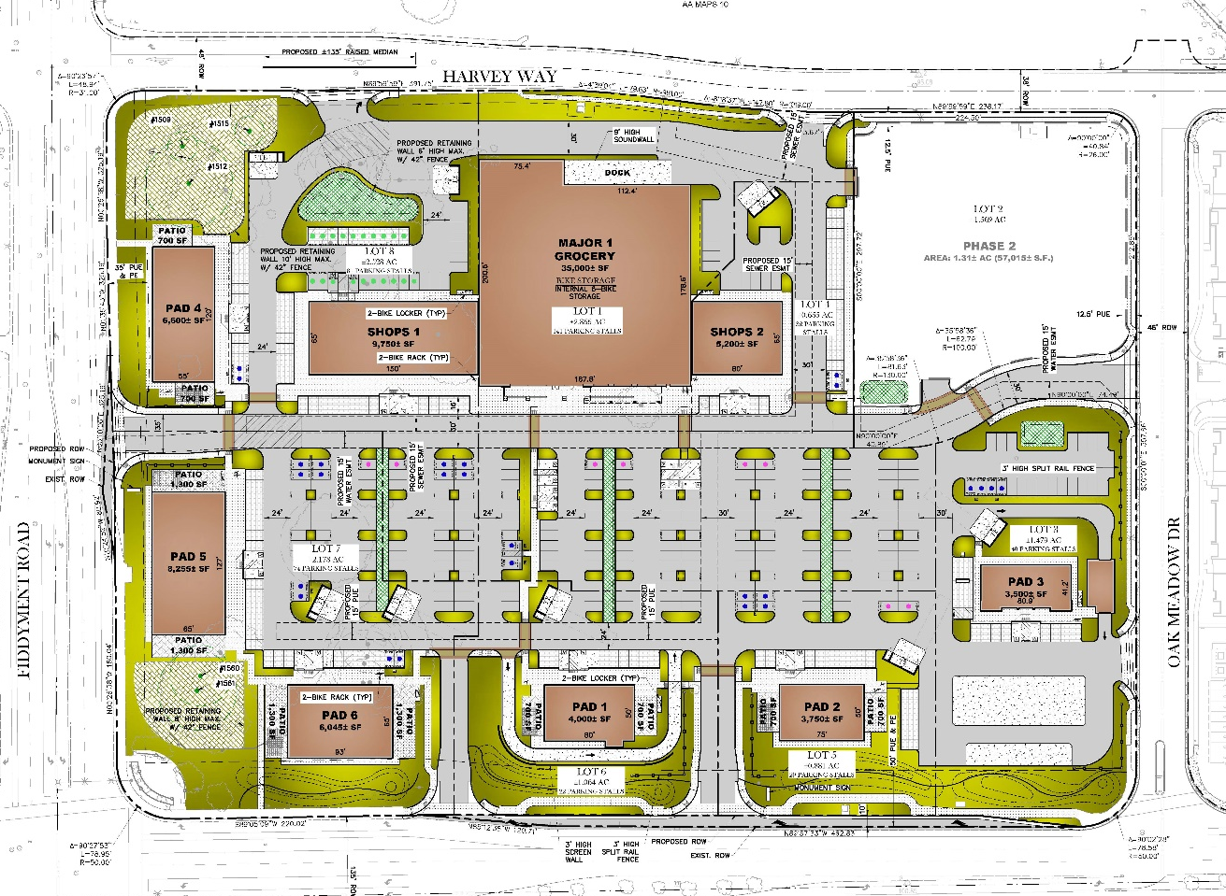
Since approval of the DRP, the Planning Division approved subsequent modifications for Pad 2 and Pad 4 in 2022. The DRP Modification for Pad 2 revised the building from a multi-tenant building to a single tenant with a drive-through to accommodate the Habit Burger Grill (file #PL21-0367). The DRP Modification for Pad 4 increased the building square footage from 6,600 square feet to 7,380 square feet and removed the outdoor patio areas to accommodate AutoZone, a retail automotive parts store (file #PL22-0111). In addition to these DRP modifications, the Design Committee approved a Design Review Permit (file #PL21-0332) in February 2022 to allow the construction of Goddard School (a daycare facility) on the northeast corner of the site. The project is currently under construction. Lastly, the Planning Division is currently processing a Design Review Permit for Pad 3 (file #PL22-0095) to allow development of the convenience store with gas station and car wash on the southeast corner of the site. The most recent site plan of the overall center, which includes the revised Pad 2 drive-through building and the larger Pad 4 building, is shown in Figure 3 below for reference.

Figure 3: Updated Plaza at Blue Oaks Site Plan
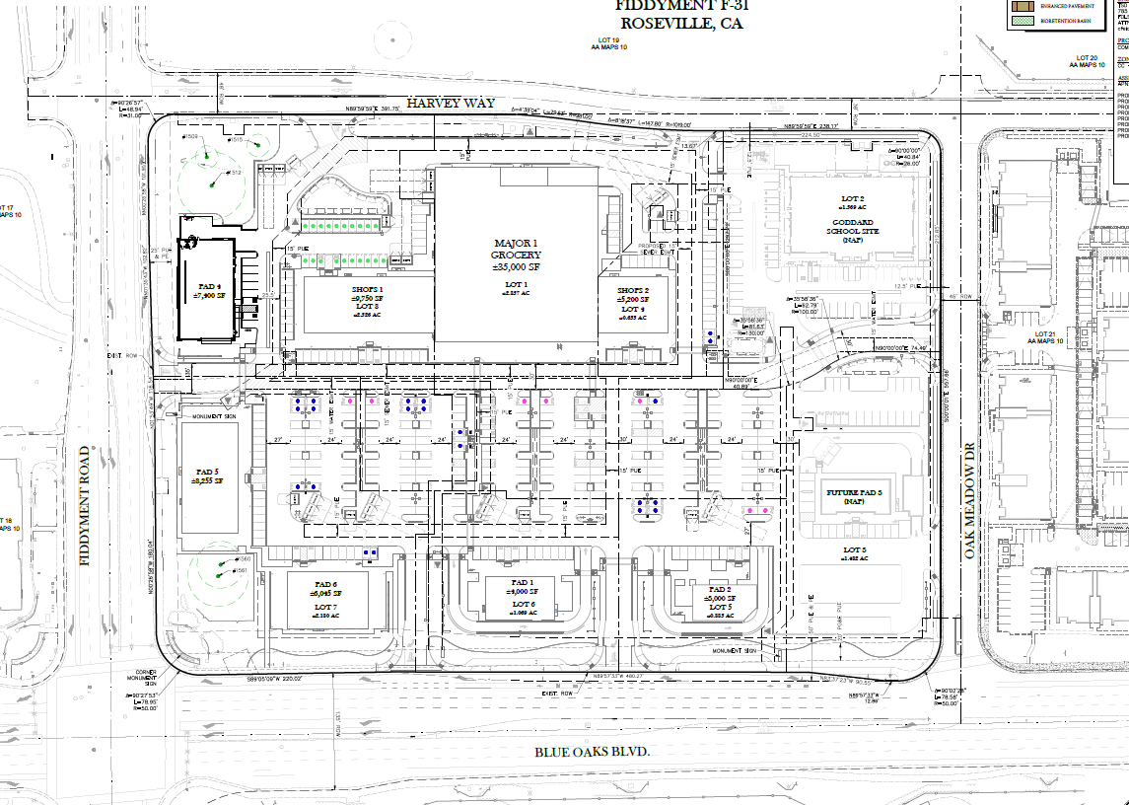
Parking for the Plaza at Blue Oaks center was based on the parking requirement for shopping centers, which is one (1) space per 200 square feet of building area. Based on the most recent site plan, the center has a total of 452 parking spaces. As tenant spaces are leased, each tenant utilizes the parking requirement for that use as outlined in Chapter 19.26 (Off-street Parking and Loading) of the Zoning Ordinance. Several of the tenant spaces have been leased out by eating and drinking establishments, which has resulted in an increase in the parking demand based on the Zoning Ordinance requirements. While the site provides 452 parking spaces, the total parking required based on the mix of uses and required park-and-ride stalls is 526 spaces. Therefore, the applicant is requesting an Administrative Permit for a 14% parking reduction for shared uses. Administrative Permits for parking reductions are typically approved at the staff level. However, parking reductions for eating and drinking establishments are to be approved by the Planning Commission per Section 19.26.030(C)(4) of the Zoning Ordinance.
EVALUATION
Section 19.78.060(A) of the City of Roseville Zoning Ordinance requires that three findings be made prior to the approval of an Administrative Permit. The required findings are listed below in italicized, bold text and are followed by an evaluation in relation to each finding.
- The proposed use or development is consistent with the City of Roseville General Plan and any applicable specific plan.

The project site has a land use designation of Community Commercial (CC). The CC land use designation is intended for retail stores and businesses selling a full range of goods and services. The existing and proposed uses include retail, eating and drinking establishments, medical services, and personal services, which are consistent with the CC land use designation. The project site is located within the WRSP, which defers to the Zoning Ordinance for regulation of permitted uses in the CC zone district.
- The proposed use or development conforms with all applicable standards and requirements of the Zoning Ordinance.

Section 19.26.030(C)(3) of the City of Roseville Zoning Ordinance contains provisions for requesting and evaluating parking reductions. It states that when an application for a parking reduction is filed, the applicant has the burden of proof for providing documentation substantiating the request. Reduced parking shall only be approved by the Planning Commission if four (4) criteria can be met. The required criteria are listed below in italics and are followed by an evaluation.

- A sufficient number of spaces are provided to meet the greatest parking demand of the participating uses.
The center requires a total of 506 parking spaces based on the Zoning Ordinance standards for the mix of uses, plus 20 spaces for a park-and-ride lot as required by the WRSP, for an overall total of 526 spaces. The site provides 452 parking spaces, resulting in a deficit of 74 spaces or approximately 14%. Exhibit A includes a parking table listing out the current and proposed uses. The uses consist of retail, eating and drinking establishments, medical office uses, personal services, a fitness user, a gas station, and a daycare. Since the center is not yet fully operating, a technical memorandum was prepared by Fehr & Peers, a transportation engineering consultant, which analyzed the greatest parking demand for the uses (see Attachment 1). As part of the analysis, Fehr & Peers conducted parking occupancy observations at the businesses listed below that would be tenants in the center and were of comparable size. These uses account for 25% of the total parking requirement for the site.
1. Chipotle Restaurant with drive-through lane at 4200 Thrive Drive in Roseville;
2. Goddard School at 2021 Wildcat Boulevard in Rocklin;
3. AutoZone at 361 Roseville Square in Roseville; and
4. The Habit Burger Grill with drive-through lane at 1368 E Main Street in Woodland.
As detailed in the technical memo, Fehr & Peers utilized the Urban Land Institute/ICSC/National Parking Association’s “shared parking spreadsheet” tool that was published in 2020 to determine the project’s most likely peak hour of parking demand. The project’s most likely peak hour of parking demand would occur on a weekday either at 12 p.m. or 1 p.m., with a secondary peak at 2 p.m. or 6 p.m. Accordingly, parking observations were made at the four locations mentioned above on each of these hours on Wednesday, August 31, 2022 and Thursday, September 1, 2022. The results are shown in Table 3 of the technical memo. The data collected demonstrates net increases or decreases in parking demand during the expected peak hours. For example, the Zoning Ordinance parking requirement for AutoZone is 1:300 (retail), amounting to 24 spaces. However, the maximum number of occupied spaces that was observed was 14 spaces at 12 p.m., resulting in a net decrease of 10 spaces. The parking requirements for these uses were adjusted based on the net increases or decreases observed, as shown in Table 4 of the technical memo and included below for reference.

Table 4 – Itemized Adjustments for Surveyed Restaurants, Stores, and Facilities
Land Use¹ | Sq. Ft.² | Time of Day Factors (as % of max)³  Unadjusted Parking Demand⁴ |  |  |  | Adjustment in Parking Demand⁵
Land Use¹ | Sq. Ft.² | 12 PM | 1 PM | 2 PM | 6 PM | 12 PM | 1 PM | 2 PM | 6 PM
Chipotle restaurant with drive-through | 2,600 | 100% | 100% | 90% | 85% | +13 | -4 | -7 | -5
Chipotle restaurant with drive-through | 2,600 | 26 | 26 | 24 | 22
Goddard School (day care) | 12,852 | 55% | 55% | 55% | 67% | +3 | -1 | -3 | -6
Goddard School (day care) | 12,852 | 26 | 26 | 26 | 31
Autozone auto parts store | 7,360 | 100% | 100% | 95% | 90% | -11 | -14 | -14 | -13
Autozone auto parts store | 7,360 | 25 | 25 | 24 | 23
Habit Burger restaurant with drive-through | 2,800 | 100% | 100% | 90% | 85% | -13 | -9 | -13 | -12
Habit Burger restaurant with drive-through | 2,800 | 28 | 28 | 25 | 24
Net Effect on Parking Demand |  |  |  |  |  | -8 | -28 | -37 | -36
Notes:
1 Only project land uses studied during data collection (in Section III) listed here.
2 Square footage planned for comparable facility at The Plaza at Blue Oaks Retail Center.
3 Time of day factors based on ULI/ICSC/NPA Shared Parking spreadsheet.
4 Unadjusted parking demand multiplies the parking requirement from the City of Roseville municipal code with the time-of-day factor for each of the four hours shown.
5 Net increase or decrease in parking need resulting from the observations in Table 3 (and in consideration of comparable site versus project size and time of day factors).
Source: Fehr & Peers, 2022.
The Chipotle restaurant results in an increase in parking demand of 13 spaces at 12 p.m. due to the peak surge observed at the comparable facility at Thrive Drive/Washington Boulevard. However, the adjustments demonstrate an overall net decrease in parking demand for the users observed during each of the anticipated peak hours. These adjustments along with the shared parking time of day adjustments were used to determine the total parking demand for the uses in the center, as shown in Table 5 of the technical memo and included below. The table shows that the maximum capacity would be 92% of the parking supply. Accordingly, this means there would be a surplus in parking during the peak demand hours. Based on the foregoing, staff anticipates there will be a sufficient number of spaces available throughout the day to meet the greatest parking demand for all of the uses located within the center.

Table 5 – Weekday Peak Hour Parking Required at The Plaza at Blue Oaks Retail Center
Land Use | Parking Required
Land Use | 12 PM | 1 PM | 2 PM | 6 PM
Retail, Supermarket, Fast Casual/Fast Food, Day Care, Health Club, and Medical Office with Shared Parking Adjustments ¹ | 400 | 422 | 412 | 399
Adjustments for specific Retail, Fast Casual/Fast Food, and Day Care uses ² | -8 | -28 | -37 | -36
Park & Ride Lot | 20 | 20 | 20 | 20
Total | 412 | 414 | 395 | 383
Parking Supply | 452 | 452 | 452 | 452
Percent of Capacity | 91% | 92% | 87% | 85%
Notes:
1 From ULI/ICSC/NPA Shared Parking spreadsheet.
2 From calculations shown in Table 4.
Source: Fehr & Peers, 2022.

- Satisfactory evidence is provided describing the nature of the uses and the times when the uses operate so as to demonstrate the lack of potential conflict between them.
According to the technical memo, retail and fast casual and fast food restaurants have slightly greater parking demands for weekends when compared to weekdays. In contrast, day care and medical office use types are busy during weekdays, but have almost no weekend demand. This offset in parking demand would reduce the potential conflict between the uses. Also, as demonstrated by the data above and in the technical memo, there is a surplus in parking during each of the anticipated peak demand hours, indicating a lack of potential conflict between the uses.
- Overflow parking will not impact any adjacent use.
There are existing reciprocal access and parking agreements in place for the center. The Zoning Ordinance does not permit designating or reserving parking spaces for specific uses within a center or complex. Although tenants will have a number of stalls allocated to them, there is no designated parking within the center with the exception of the required 20 park-and-ride spaces. Typically park-and-ride spaces are reserved for park and ride uses Monday through Friday from 6:30 a.m. to 6:30 p.m. However, it is not anticipated that overflow parking will occur due to the operational characteristics and parking demands of the mix of uses. However, should additional parking be needed, on-street parking is allowed along Harvey Way and Oak Meadow Drive immediately adjacent to the project site.

- Additional documents, covenants, deed restrictions, or other agreements as may be deemed necessary by the Planning Manager are executed to assure that the required parking spaces provided are maintained and uses with similar hours and parking requirements as those uses sharing the parking facilities remain for the life of the project.
As mentioned above, there are existing reciprocal access and parking agreements in place to ensure the access and parking spaces are shared among the center. Conditions of approval to this Administrative Permit indicate that the permit will no longer be valid if the mix, square footage, and operating characteristics described herein are changed.
- The location, size, design, and operating characteristics of the use or development is compatible with and shall not adversely affect or be materially detrimental to the health, safety, or welfare of persons residing or working in the area, or be detrimental or injurious to public or private property or improvements.

As discussed above, a sufficient number of spaces are provided to meet the greatest parking demand of the participating uses, and the nature of the uses and times when the uses operate demonstrate the lack of potential conflict between them. Staff finds the project is compatible with and shall not adversely affect or be materially detrimental to the health, safety, or welfare of persons residing or working in the area, or be detrimental or injurious to public or private property or improvements.
PUBLIC OUTREACH
The proposed project was distributed to all internal and external agencies and departments who have requested such notice, and all comments or recommended conditions of approval have been incorporated into the project, as appropriate. Early notification of the project was posted on the Roseville Coalition of Neighborhood Associations (RCONA)’s website. A notice of the public hearing was published in the Roseville Press Tribune on September 30, 2022 and a notice of the hearing was also distributed to all property owners within 300 feet of the site and posted on the RCONA website. No comments have been received as of publication of this report.

ENVIRONMENTAL DETERMINATION

The project is categorically exempt from the provisions of the California Environmental Quality Act (CEQA) pursuant to CEQA Guidelines Section 15305, Minor Alterations to Land Use Limitations, and pursuant to Section 305 of the City of Roseville CEQA Implementing Procedures. Consistent with the exemption classification, the project does not result in any changes in land use or density.

RECOMMENDATION

The Planning Division recommends the Planning Commission take the following actions:
- Adopt the three (3) findings of fact and approve the ADMINISTRATIVE PERMIT – 1950 BLUE OAKS BOULEVARD – WRSP PCL F-31 – PLAZA AT BLUE OAKS PARKING REDUCTION – FILE #PL22-0337 subject to three (3) conditions of approval.

CONDITIONS OF APPROVAL FOR THE ADMINISTRATIVE PERMIT – FILE #PL22-0337
- This Administrative Permit for a reduction of seventy-four (74) spaces is approved based on the proposed mix, square footage, and operating characteristics of tenants and tenant spaces, as described in this staff report and in Attachment 1 and Exhibit A, and as conditioned below. Should the uses vacate the space or modify operations, the parking reduction will no longer be valid. (Planning)

- This Administrative Permit approval shall be effectuated within a period of two (2) years from October 13, 2022 and if not effectuated shall expire on October 13, 2024. Prior to said expiration date, the applicant may apply for an extension of time. (Planning)

- The applicant shall submit plans to the Building Division and secure a building permit for any proposed tenant improvements. (Building)

ATTACHMENT
- Fehr & Peers Technical Memorandum

EXHIBIT
- Parking Table

Note to Applicant and/or Developer: Please contact Planning Division staff at (916) 774-5276 prior to the Commission meeting if you have any questions on any of the recommended conditions for your project. If you challenge the decision of the Commission in court, you may be limited to raising only those issues which you or someone else raised at the public hearing held for this project, or in written correspondence delivered to the Planning Manager at, or prior to, the public hearing.

